**JPA**

The Java Persistence API (JPA) is **a specification of Java**. It is used to persist data between Java objects and relational databases. JPA acts as a bridge between object-oriented domain models and relational database systems. As JPA is just a specification, it doesn't perform any operation by itself.

JPA cannot be used directly in the project, it has to be used with an ORM tool i.e(Hibernate or iBatis)

Different DBMSs have different connectors to connect to the database. Its dependency has to be mentioned in the pom.xml file.

Steps to use JPA in project

1. Use any ORM tool like hibernate into the project by mentioning its dependency in pom.xml file
2. Create entity manager factory object and entityManager object to perform any database operation.

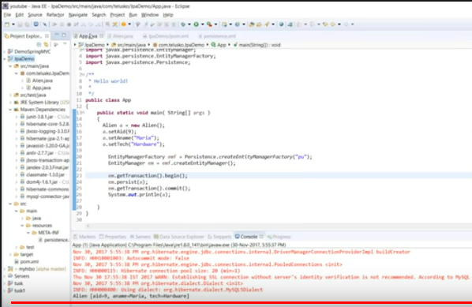

1. Create persistence.xml file as mentioned in folder and enter the required specifications like driver name,url,pswd and mention the persistence unit name while creating entityManagerFactory object. Inorder to specify that request should go to which database.

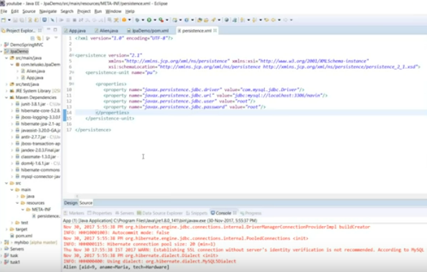

Detailed explanation - <https://www.javatpoint.com/jpa-tutorial>

**Advanced Java Interview Questions**

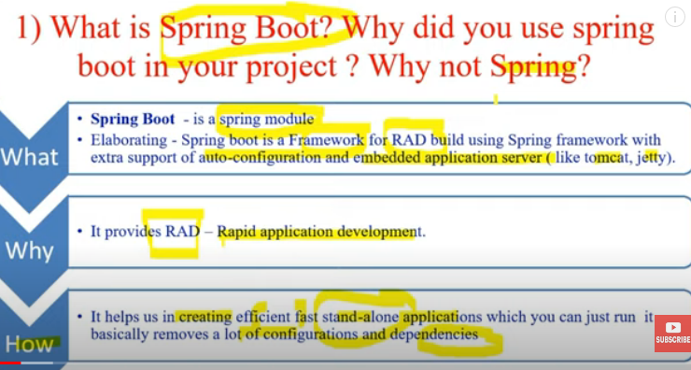

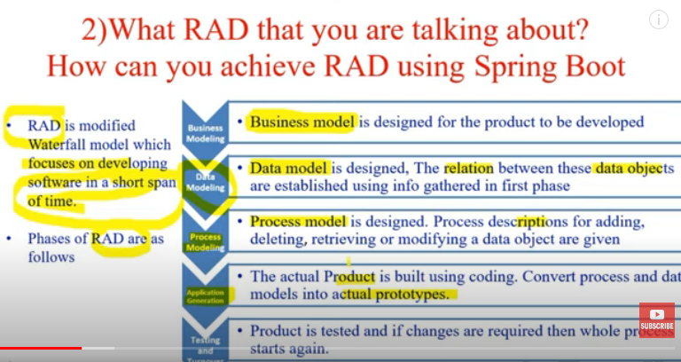

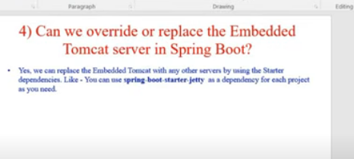

In this case we need to exclude the tomcat dependency and from spring-starter-web dependency and include dependency of server we need to add in pom.xml

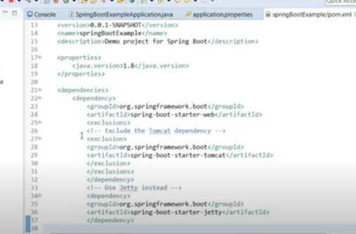

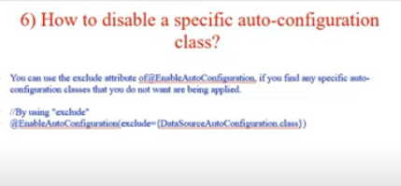

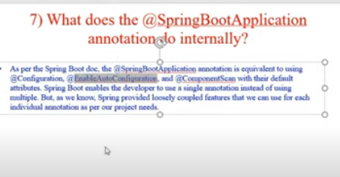

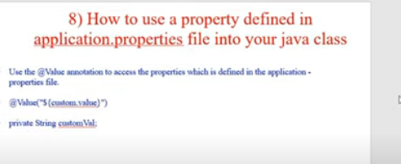

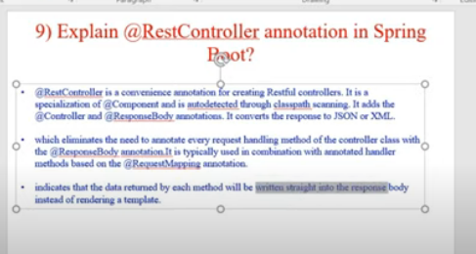

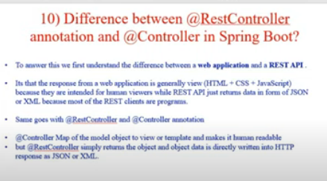

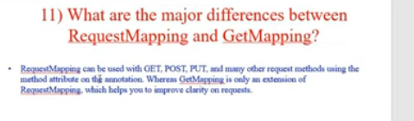

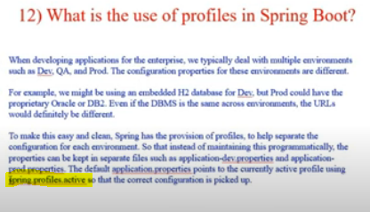

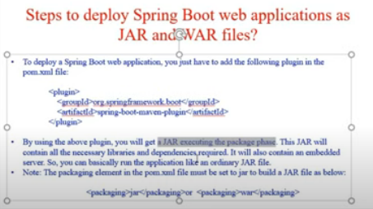

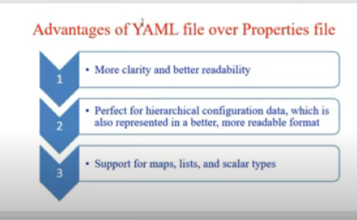

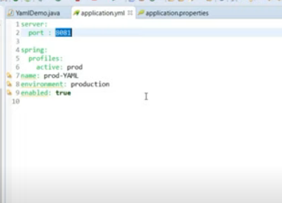

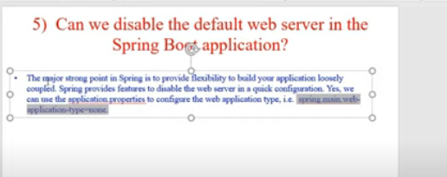

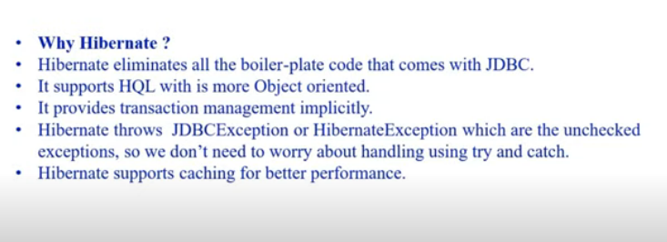

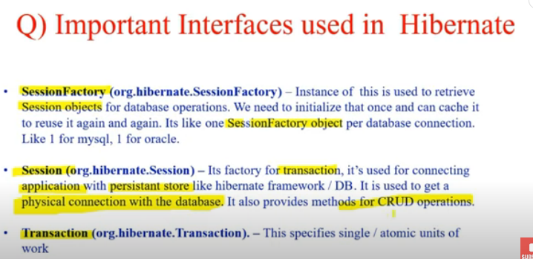

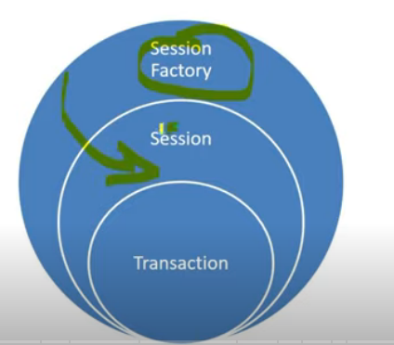

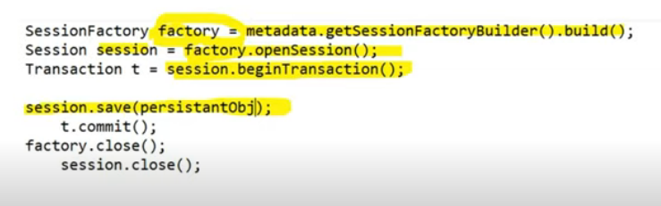

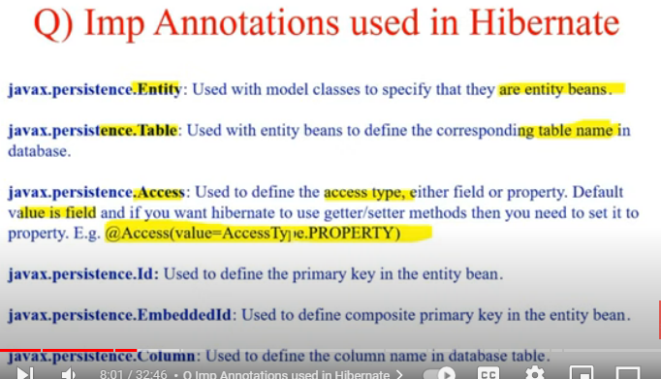

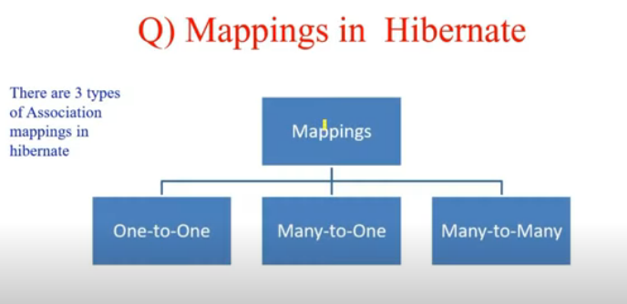

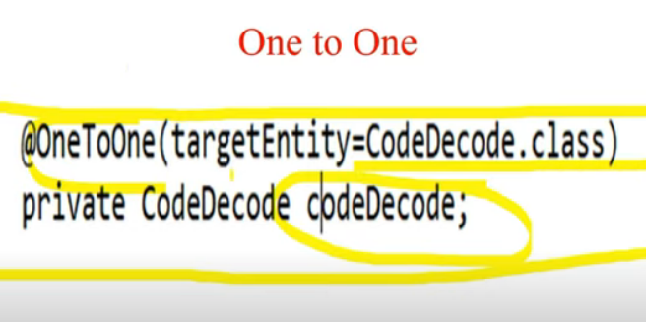

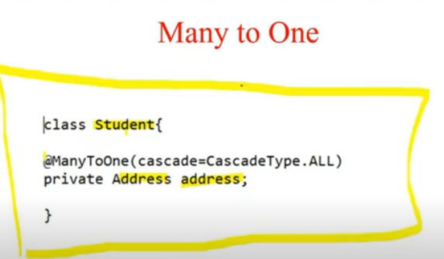

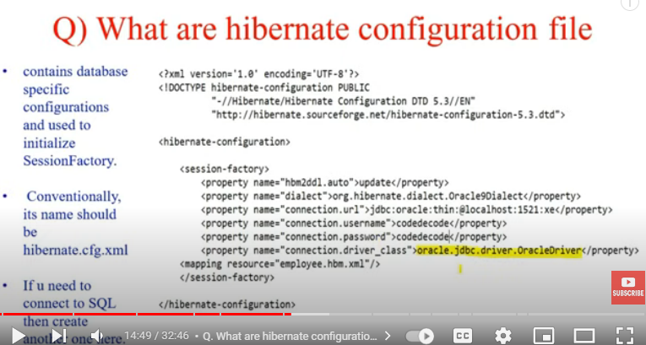

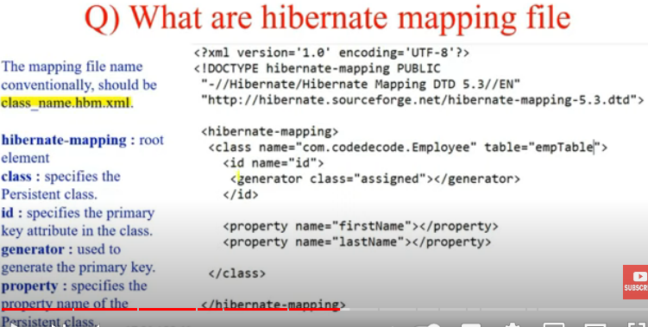

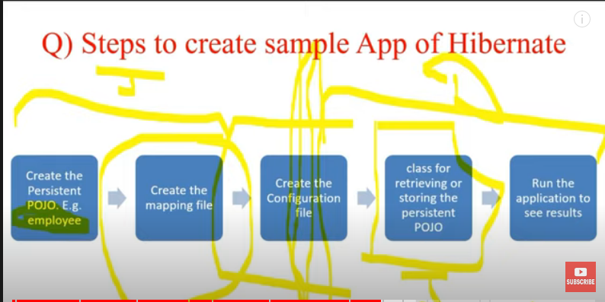

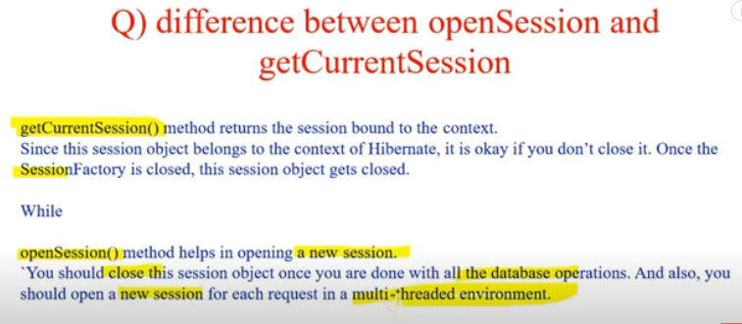

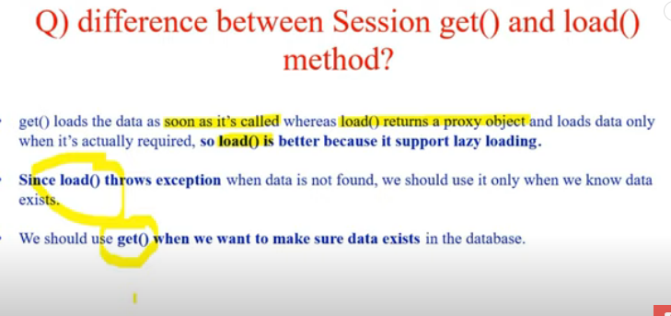

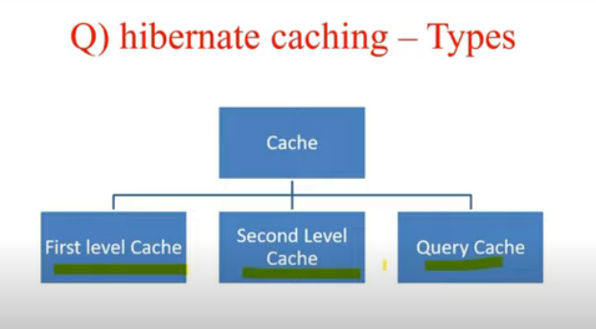

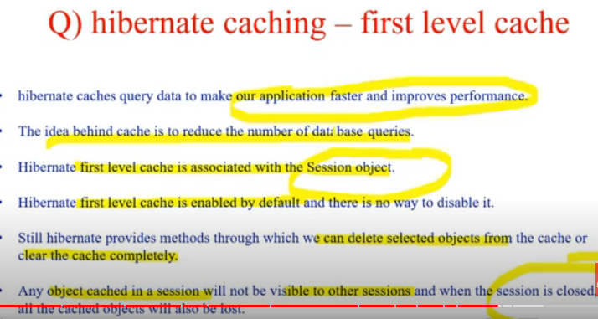

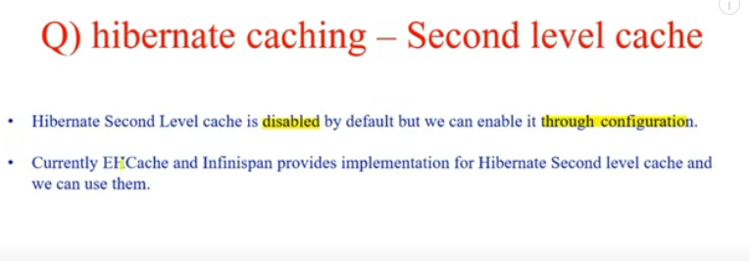

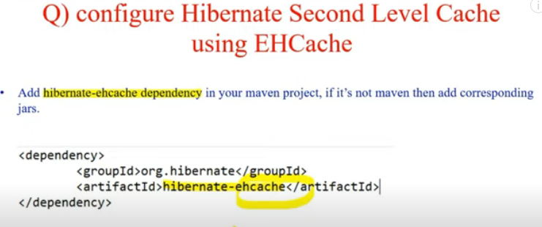

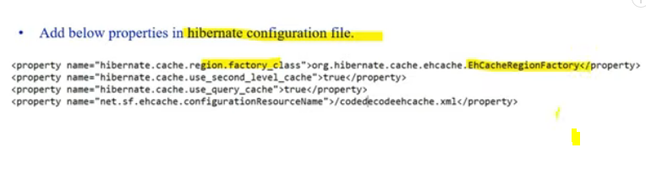

Query level cache should be used with second level cache, before making query level cache true make second level cache true.

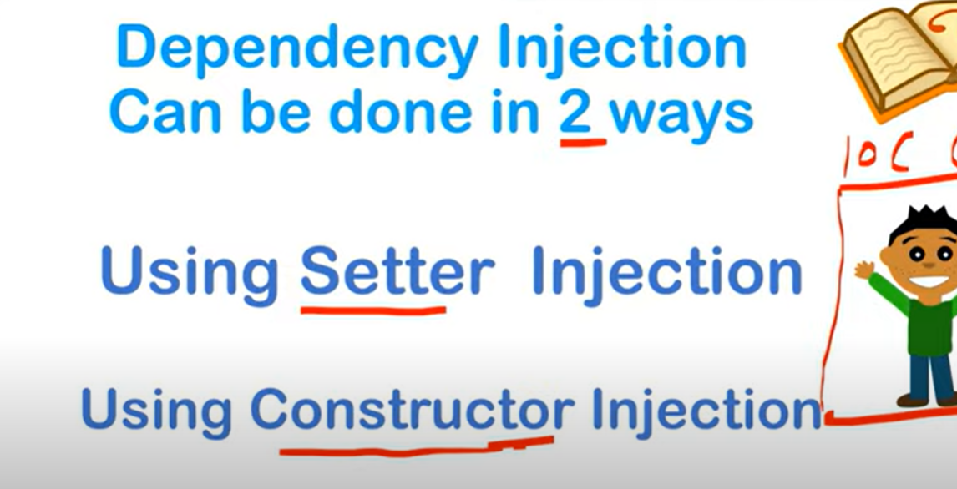

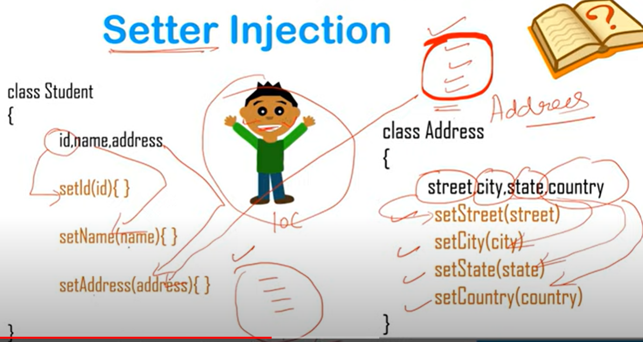

Setter Injection is used to inject properties of objects using setters. It is also called property injection.

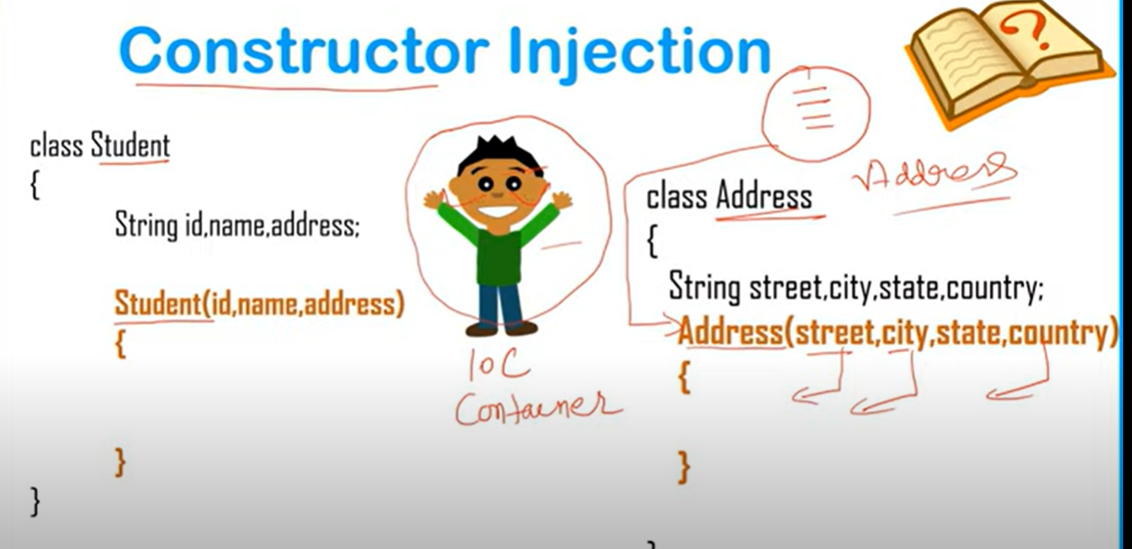

Constructor Injection is used to inject properties of object using constructors.

**Scope of Beans in Spring**

The few most commonly used bean scopes in spring are:

1. Singleton – In this each time, same object is provided by Spring IOC Container. This can 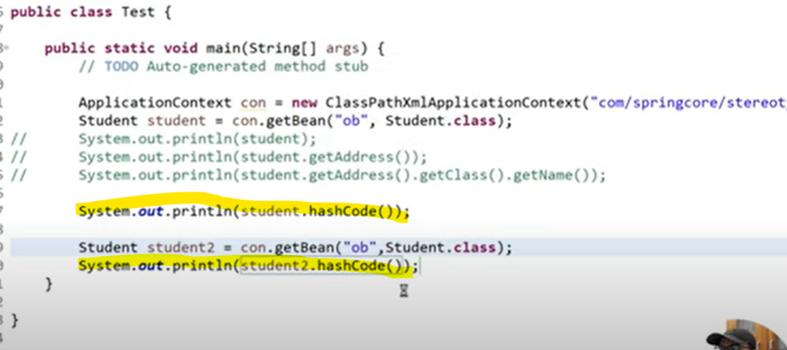be compared used hashCode of that object. As displayed below, highlighted hashcode would be same.
2. Prototype – In this each time, new object is provided by Spring IOC Container

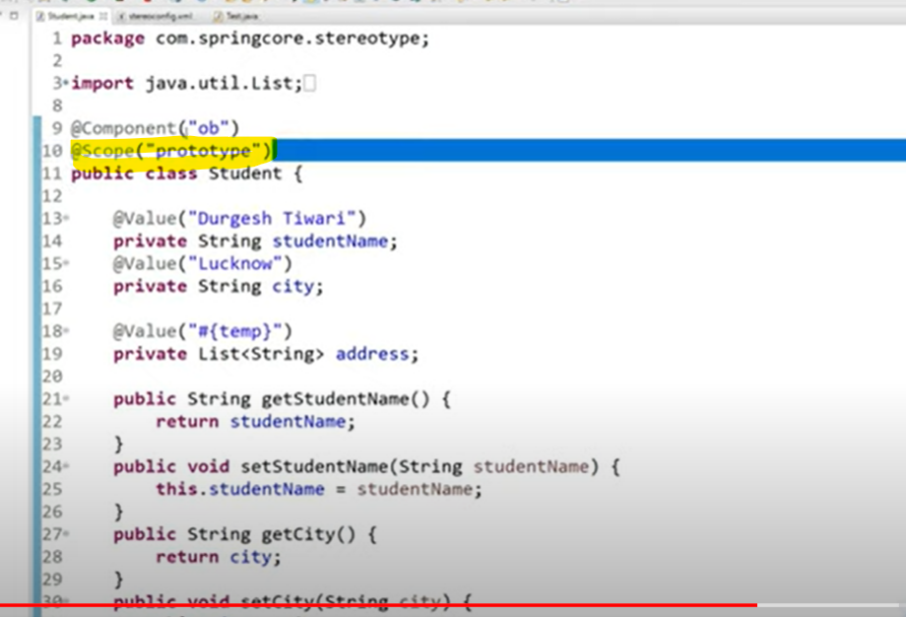

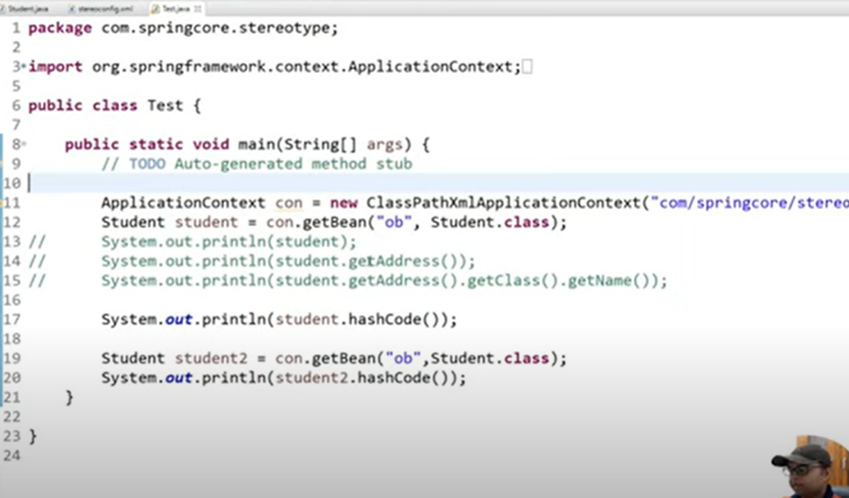

1. Request – For every http request new object is created.

Default scope of any spring bean is Singleton.

Bean can be declared using Annotation as well apart from XML configuration file.

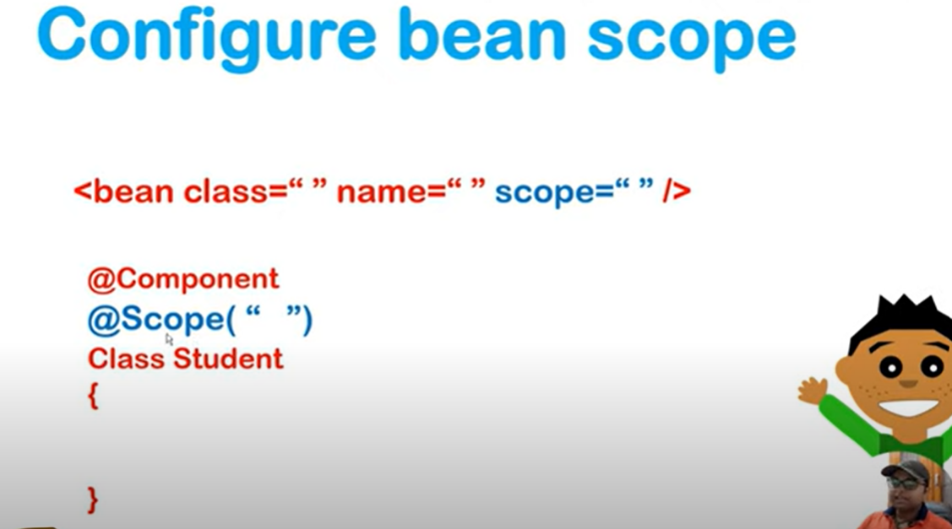

**Spring Framework**

Spring framework manages the creation and lifecycle of objects.

@ComponentScan is used to scan component (by scanning the packages). In Spring boot, it scans in package where @SpringBootApplication is mentioned.

If spring is not able to find bean, there may be 2 scenarios:

1. @Component is missing in that particular class.
2. Class is in package which is not getting scanned.

**Spring Bean**: It is object managed by spring framework.

**IOC Container**: It manages the lifecycle of beans and dependencies.

Types of IOC container: Application Context (mostly used), Bean Factory

**Autowiring**: Process of wiring in dependencies for a Spring Bean

There are different layers of a web application(structure of application)

1. Web Layer: It is responsible for UI logic.
2. Business Layer: It is for business for business logic.
3. Data Layer: It talks with the database.

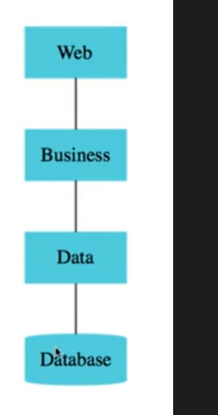

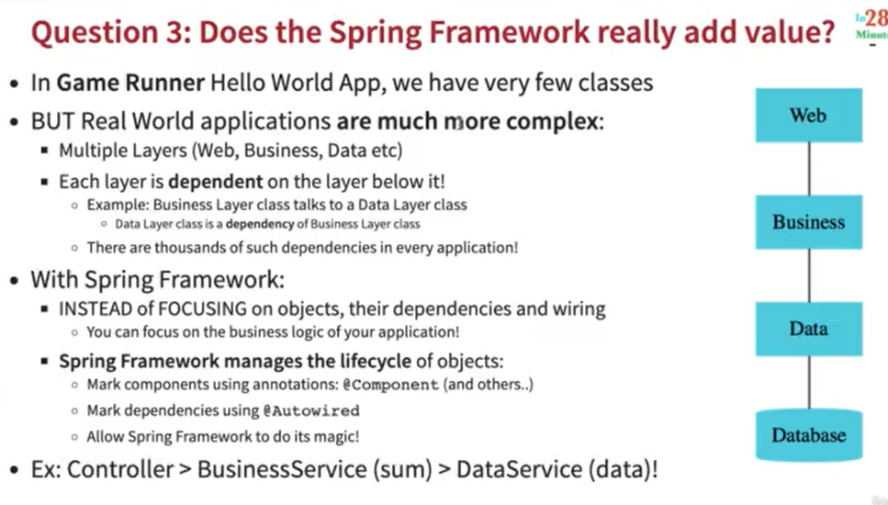

In maven artifacts, group id is like a package and artifact id is a class.

In Spring boot , dependency injection can be done in three ways:

1. Constructor Injection(This is recommended to use)
2. Setter Injection(@Autowired needs to be mentioned above setter)
3. Field Injection